# V gt



**SMART CARD-ENABLED CHARGING SYSTEM FOR ELECTRIC VEHICLES**

##### A PROJECT REPORT

###### ***Submitted by***

##### ARUNDHATHI.T [REGISTER NO:211421104028]

**CHARMINE MARIA THOMAS [REGISTER NO:211421104043]**

***in partial fulfillment for the award of the degree***

***of***

**BACHELOR OF ENGINEERING**

IN

# COMPUTER SCIENCE AND ENGINEERING

PANIMALAR ENGINEERING COLLEGE, CHENNAI-600123.

##### OCTOBER 2023

**BONAFIDE CERTIFICATE**

Certified that this project report “**SMART CARD-ENABLED CHARGING SYSTEM FOR ELECTRIC VEHICLES**” is the bonafide work of **“ARUNDHATHI.T (211421104028)**, **CHARMINE MARIA THOMAS (211421104043)”** who carried out the project work under my supervision.

**SIGNATURE SIGNATURE**

**Dr.L.JABASHEELA .,M.E.,Ph.D., Dr. T.TAMILVIZHI M.Tech.,Ph.D**

**HEAD OF THE DEPARTMENT SUPERVISOR, PROFESSOR**

DEPARTMENT OF CSE, DEPARTMENT OF CSE,

PANIMALAR ENGINEERING COLLEGE, PANIMALAR ENGINEERING COLLEGE,

NASARATHPETTAI, NASARATHPETTAI,

POONAMALLEE, POONAMALLEE,

CHENNAI-600 123. CHENNAI-600 123.

Certified that the above candidates were examined in the End Semester Project Viva

Voce Examination held on...........................

**INTERNAL EXAMINER EXTERNAL EXAMINER**

**DECLARATION BY THE STUDENT**

We ARUNDHATHI.T (211421104028), CHARMINE MARIA THOMAS (211421104043)hereby declare that this project report titled “**SMART CARD-ENABLED CHARGING SYSTEM FOR ELECTRIC VEHICLES” ,** under the guidance of DR.T.TAMILVIZHI is the original work done by us and we have not plagiarized or submitted to any other degree in any university by us.

**NAME OF THE STUDENT**

**1. ARUNDHATHI.T(211421104028)**

**2.CHARMINE MARIA THOMAS (211421104043)**

**ACKNOWLEDGEMENT**

We would like to express our deep gratitude to our respected Secretary and Correspondent **Dr.P.CHINNADURAI, M.A., Ph.D.** for his kind words and enthusiastic motivation, which inspired us a lot in completing this project.

We express our sincere thanks to our Directors **Tmt.C.VIJAYARAJESWARI**, **Dr.C.SAKTHI KUMAR,M.E.,Ph.D** and **Dr.SARANYASREE SAKTHI KUMAR B.E.,M.B.A.,Ph.D.,** for providing us with the necessary facilities to undertake this project.

We also express our gratitude to our Principal **Dr.K.Mani, M.E., Ph.D.** who facilitated us in completing the project.

We thank the Head of the CSE Department, **Dr. .JABASHEELA , M.E.,Ph.D.,** for the support extended throughout the project.

We would like to thank our project guide DR.T.TAMILVIZHI and all the faculty members of the Department of CSE for their advice and encouragement for the successful completion of the project.

**NAME OF THE STUDENTS**

**1. ARUNDHATHI.T(211421104028)**

**2.CHARMINE MARIA THOMAS (211421104043)**

**ABSTRACT**

Today in our current scenario, the level of pollutants being emitted into the atmosphere is increasing daily. And there is an urgent need for the people to adapt to environmentally friendly alternatives. As the survey report suggests, the pollutants from vehicles contribute to a major extent which leads to the urgent need to adapt to carpooling, use of motor cycles, shift to environmentally friendly vehicles. The need for a cleaner environment has driven the development of cost-effective green vehicle technology, such as electric vehicle. Electric vehicles (EVs) are a notable innovation to reduce the impact of vehicles running on petrol and diesel. The proposed system is “**SMART CARD-ENABLED CHARGING SYSTEM FOR ELECTRIC VEHICLES”.** Electric vehicle (EV) charging using radiofrequency identification (RFID) is a new technology that enables electric vehicles to be charged through a connector by implementing the concept of the Internet of things. The introduction of RFID technology enables secure user identification and payment, ensuring a more accessible and practical EV charging experience. This system integrates hardware components like NodeMCU ESP8266 microcontroller, RFID scanner, LCD display, and relays with software components like Arduino IDE, Google Firebase, and MIT App Inventor to create a seamless and user-friendly charging experience for EV owners. The proposed system is an electric vehicle charging station with smart card technology. The vehicle is first connected to the charging station using a connector and the system then obtains the amount of charge present in the vehicle. The RFID card is placed on the device, the device first checks the amount required to charge the vehicle. If sufficient quantity is present, the device debits the amount required for charging and starts charging and the system charges the vehicle accordingly and disconnects the charge and the availability of the next charging station is also displayed by the device. If the vehicle requires a higher amount of charging, while the amount is less then the vehicle is charged only as per the amount available. The total time and other information required is displayed using the LCD display in the charging station.

TABLE OF CONTENTS

| **CHAPTER NO.** | **TITLE** | **PAGE NO.** |
| --- | --- | --- |
|  | **ABSTRACT** | iii |
|  | **LIST OF TABLES** | vii |
|  | **LIST OF FIGURES** | viii |
|  | **LIST OF SYMBOLS, ABBREVIATIONS** | ix |
| **1.** | **INTRODUCTION** |  |
|  | 1.1 Organization Profile |  |
|  | 1.2 Problem Definition |  |
| **2.** | **LITERATURE SURVEY** |  |
| **3.** | **SYSTEM ANALYSIS** |  |
|  | 2.1 Existing System |  |
|  | 2.2 Proposed system |  |
|  | 2.3 Feasibility Study |  |
|  | 2.4 Hardware Environment |  |
|  | 2.5 Software Environment |  |
| **4.** | **SYSTEM DESIGN** |  |
|  | 4.1. ER diagram |  |
|  | 4.2 Data dictionary |  |
|  | 4.3 Table Normalization |  |
|  | 4.4 Data Flow Diagram |  |
|  | 4.5 UML Diagrams |  |
| **5.** | **SYSTEM ARCHITECTURE** |  |
|  | 5.1 Architecture Overview  5.2 Module Design Specification (Description of the Modules) |  |
|  | 5.2 Algorithms |  |
| **6.** | **SYSTEM IMPLEMENTATION** |  |
|  | 6.1 Client-side coding (sample) |  |
|  | 6.2 Server-side coding(sample) |  |
| **7.** | **SYSTEM TESTING** |  |
|  | 7.1 Unit Testing |  |
|  | 7.2 Integration Testing |  |
|  | 7.3 Test Cases & Reports |  |
| **8.** | **CONCLUSION** |  |
|  | 8.1 Conclusion and Future Enhancements |  |
|  | **APPENDICES** |  |
|  | A.1 Sample Screens |  |
|  | A.2 Publications  A.3 Plagiarism Report |  |
|  | **REFERENCES** |  |

**CHAPTER 1**

**INTRODUCTION**

The Internet of Things (IoT) is a network of real-world items that can communicate with one another over the internet with technology and sensors. IoT devices enable seamless communication between the physical and digital worlds and range from commonplace objects to industrial machines. IoT devices collect and share data autonomously, utilizing low-cost computing, cloud technology, big data, analytics, and mobile technology, improving efficiency and decision-making across numerous industries. As these items evolve into intelligent beings that combine the digital and physical worlds, human engagement with IoT devices is minimal and typically restricted to setup.

Systems that are controlled by internet is termed as “Smart”. Smart-IoT systems learn, perceive, and make real-time decisions, transforming data from IoT sensors into actionable insights. These systems detect, respond, and act appropriately based on analyzed and validated data. Electric-vehicles play an effective role in reducing greenhouse gases emission by the transportation sector.

Smart EV charging, a part of IoT, involves a system where electric vehicles and charging devices share data connections. Intelligent charging manages when and how an electric vehicle receives power based on factors like electricity cost and driver needs. To facilitate electric vehicle popularity, convenient public charging facilities are crucial. Charging stations operate unattended, necessitating self-service operations. Integrating RF technology into charging solutions, such as smart cards, streamlines transactions. An EV Charging Card, or EV Charging Smart Card, is a contactless card that uses radio-frequency identification (RFID) technology to communicate with the EV charger. An EV Smart Card often works with an application on a smartphone or other device that allows the user to activate the charging process and automatically bills their account. Smart EV charging optimizes energy usage, monitors battery charge, and handles billing. This system also requires communication between chargers, energy resources, the grid, and charging operators' platforms, managed by centralized cloud-based software.

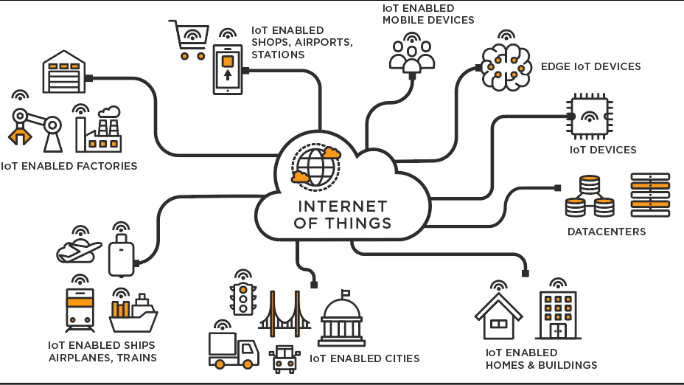

# ORGANIZATION PROFILE

# 

We requested the Founder and Director of Crystal Clear Technology and Innovation **Mr. RANJITHKUMAR MAHALINGAM** through email to provide us with a mini project to work on. **CRYSTAL CLEAR TECHNOLOGY & INNOVATION** is a specialized R&D and training division for Embedded Systems, IoT and Software.

CCTI is a technical partner to provide solutions to some of the industries in and around Tamil Nadu. They also provide a solution to motor and pump manufacturing industries to test their products using LabVIEW, IoT and Embedded systems.

The company gave us the opportunity to work on their existing project titled

“ **SMART CARD-ENABLED CHARGING SYSTEM FOR ELECTRIC VEHICLES**”. We were given the opportunity to work on a part of the overall project. We are aware only of our module components and working since the entire project discussion violates the norms of the company.

# 1.2 PROBLEM DEFINITION

Electric vehicles are a notable innovation to reduce the impact of vehicles running on petrol and diesel. They prove to be environmentally friendly as their batteries are emission-free and can be drained and charged repeatedly without contributing to air pollution. EVs contribute to lower emissions than ICE vehicles. EV manufacturers use eco-friendly materials to create lighter, more efficient vehicles. Completely natural or recycled materials reduce environmental impact during and after the EV production process. The need for a cleaner environment has driven the development of cost-effective green vehicle technology such as electric vehicles. The better and more efficient the charging system of electric vehicles, the more likely people will be to adopt e-vehicles. As the number of electric vehicles on the road increases, charging infrastructure is becoming increasingly important. Electric vehicle (EV) wireless charging using radiofrequency identification (RFID) is a new technology that offers several benefits over traditional wired charging systems. RFID provides a cost-effective solution to identifying and authorizing vehicles for charging and will allow EV charging to operate effectively while considering grid constraints and meeting the needs of EV drivers.

This technology is more efficient, with minimal energy loss, and reduces the risk of electrical hazards. It is suitable for both indoor and outdoor charging applications. EV wireless charging using RFID is a promising technology that could potentially revolutionize the EV charging industry. It offers many benefits including increased convenience, efficiency and safety, and has the potential to significantly reduce the environmental impact of transport.

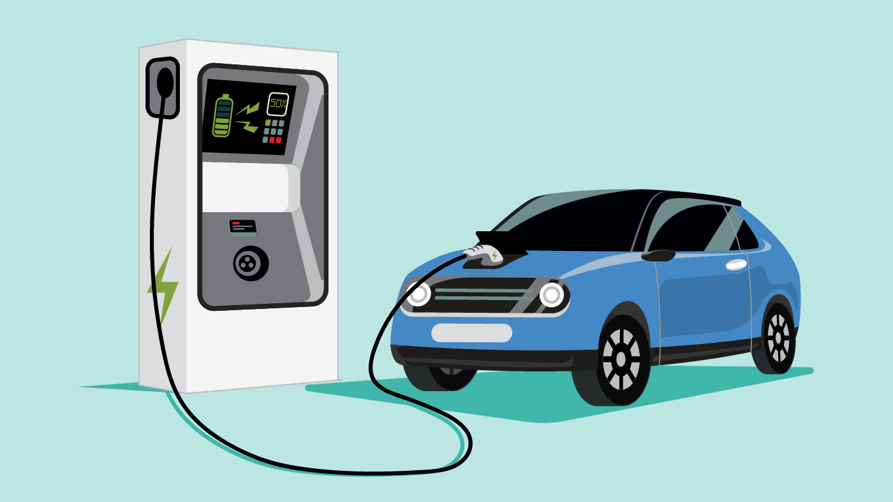

# CHAPTER 2

# LITERATURE SURVEY

**TITLE: SMART CARD FOR SECURE PAYMENT APPLICABLE TO ELECTRIC VEHICLES CHARGING, Year: 2014**

**AUTHORS:**

* **Kuilin chen**

Communication & power Utilization Technology Subcompany

* **Dongyan Zhao**

Communication & power Utilization Technology Subcompany

* **Haifeng Zhang**

Communication & power Utilization Technology Subcompany

**ABSTRACT**:

The growth of electric vehicles depends on convenient charging infrastructure. Since charging stations are often unmanned, a smart card system is vital. Smart cards can securely handle user identification and payment. They are used for communication with charging stations, ensuring a user-friendly and secure charging experience. This technology plays a crucial role in making electric vehicles more accessible and practical for users worldwide.

**TITLE**: **SMART ELECTRIC VEHICLE CHARGING USING RFID,**

**YEAR: 2020**

**AUTHORS:**

* **Ajithkumar**

Student,Department of Electrical and Electronics Engineering, Paavai Engg. College, Namakkal, India.

* **M. Ajithkumar**

Student,Department of Electrical and Electronics Engineering, Paavai Engg. College, Namakkal, India.

* **S. Gopi**

Student,Department of Electrical and Electronics Engineering, Paavai Engg. College, Namakkal, India.

* **V.G. Balajisabarinathan**

Student,Department of Electrical and Electronics Engineering, Paavai Engg. College, Namakkal, India.

* **Mr. C. Gowrishankar**

Assistant professor,Department of Electrical and Electronics Engineering, Paavai Engg. College, Namakkal, India.

**ABSTRACT:**

Wireless electric vehicle (EV) charging with RFID technology is a new way to charge EVs without cords. It uses RFID tags on the EV to communicate with a charging pad through electromagnetic fields. When the RFID reader detects the EV with the tag, it activates the charging pad, and power transfer begins. This technology is better than wired charging because it eliminates connectors, reduces wear, and is more efficient and safer. It's also weather-resistant, suitable for indoor and outdoor use, and has the potential to improve EV charging convenience, efficiency, and environmental impact.

**TITLE: REVOLUTION IN ELECTRIC VEHICLE,**

**YEAR:2021**

**AUTHORS:**

* **Amandeep Sagwal**

Physics Department, DAV College, Sector 10, Chandigarh 160011, India.

* **Paras Agrawal**

Physics Department, DAV College, Sector 10, Chandigarh 160011, India.

* **Randeep**

Physics Department, DAV College, Sector 10, Chandigarh 160011, India.

* **Mangladeep Bhullar**

Physics Department, DAV College, Sector 10, Chandigarh 160011, India.

**ABSTRACT:**

Electric vehicles are making a significant impact in reducing greenhouse gas emissions in transportation. Battery, hybrid, plug-in hybrid, and fuel cell electric vehicles are gaining prominence in automotive research. This article discusses the latest advancements in electric vehicle technology, covering types, innovations in motors and batteries, applications, future prospects, and challenges in the electric vehicle industry.

**TITLE: ELECTRIC VEHICLE CHARGING OPEN PAYMENT,**

**YEAR:2021.**

**COMPANY:**

**SECURE TECHNOLOGY ALLIANCE**

**ABSTARCT:**

This document describes a future where electric vehicle (EV) owners can easily charge their cars at any station and make payments without the need for accounts or memberships. Charging would be as straightforward as connecting the cable. To enable this, open payment technology, known for its security and compatibility, builds upon chip cards, mobile payments, and tokenization, offering a strong foundation for user-friendly and secure EV charging systems worldwide.

**TITLE: SMART CARD BASED ELECTRIC VEHICLE CHARGING STATION, YEAR:2022**

**AUTHORS:**

* **Dr. Manoj Dhondiram Patil**

Associate Professor, Department of Electrical Engineering

* **Mr. Suraj More**

UG Students, Department of Electrical Engineering

* **Mr. Pranav Patil**

UG Students, Department of Electrical Engineering

* **Mr. Rohit Mortale**

UG Students, Department of Electrical Engineering

* **Miss. Komal Kho**

UG Students, Department of Electrical Engineering

Anna Saheb Dange College of Engineering & Technology, Ashta, Sangli, Maharashtra, India

**ABSTRACT:**

The demand for cleaner transportation has led to the development of cost-effective green technologies like electric vehicles (EVs). With more EVs on the road, the charging infrastructure's significance grows. However, there are challenges in enhancing its efficiency and understanding EV charging patterns. This paper explores RFID (radio frequency identification) technology to automatically identify users. It utilizes electromagnetic waves for data transmission between users and the system, addressing these issues in EV charging**.**

**TITLE: SMART CARD WIRELESS CHARGING USING RFID,**

**YEAR:2023**

**AUTHOR:**

* **Joyce Jacob**

Professor, Department of Electronics and Communication Engineering Prince Shri Venkateshwara Padmavathy Engineering College, Chennai, Tamil Nadu, India

* **Abinaya. S**

Professor, Department of Electronics and Communication Engineering Prince Shri Venkateshwara Padmavathy Engineering College, Chennai, Tamil Nadu, India

* **Divya Priya. R**

Professor, Department of Electronics and Communication Engineering Prince Shri Venkateshwara Padmavathy Engineering College, Chennai, Tamil Nadu, India

* **Ms.Poonam Khatarka**

Department of Electrical & Electronics Engineering, IES College Of Technology, Bhopal, MP

* **Abdullaeva**

Tashkent State Pedagogical University, Tashkent, Uzbekistan

* **Sathish Kumar. G**

Assistant professor, Department of mechanical Engineering, K. Ramakrishnan college of technology, Tiruchirappalli

**ABSTRACT:**

In order to balance grid demands and serve EV customers, charging infrastructure is becoming increasingly important as the number of Electric Vehicles (EVs) increases. In a smart charging network, this study suggests an RFID system for user identification and charging authorisation. In order to identify and authorise vehicles for effective charging, ensure grid compatibility, and satisfy the needs of EV drivers, RFID offers a cost-effective solution. Voltage levels are used to manage charging, and the technology enables real-time, global IoT monitoring of charging status.

**CHAPTER 3**

**SYSTEM ANALYSIS**

# 3.1 EXISTING SYSTEM

Electric vehicle wireless charging is an emerging technology that aims to provide a convenient and efficient way to charge electric vehicles without the need for physical cables. The RFID (radio-frequency identification) wireless charging system for electric vehicles is a technology that enables electric vehicles to be wirelessly charged using a magnetic field produced by a charging station. It is straightforward and simple for EV owners to charge their vehicles without physically attaching a charging wire to the car , which employs RFID technology to authenticate the vehicle and start the charging process. The charging pad and the RFID tag are the two major parts of the system. The ground-mounted charging station creates a magnetic field that an induction coil in the car uses to wirelessly transmit energy to the battery. The RFID tag is attached to the car and includes details about it, including its identification number, battery size, and charging specifications.

# 3.2 LIMITATIONS OF EXISTING SYSTEM

* Time- consuming
* Cannot charge multiple vehicles at the same time
* Cost of setting up the wireless charging station is high.

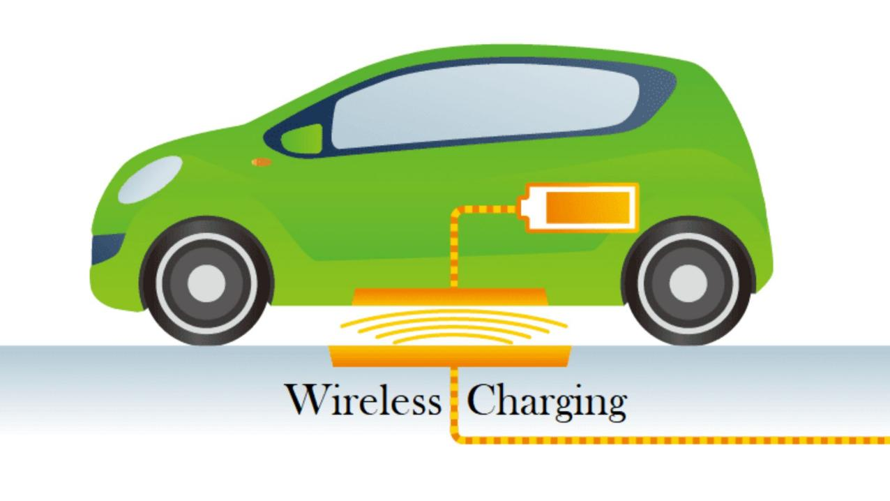

# 3.3 PROPOSED SYSTEM

The proposed system is an electric vehicle charging station with smart card technology. The vehicle is first connected to the charging station using a connector (charging cable). The system then obtains the amount of charge present in the vehicle. The RFID card is provided to the user along with the vehicle at the time of purchase. The RFID card is linked to the Google-database and the information is stored. The user must first scan the smart card on the device. The card is recharged before use. When the card is placed on the device, the device receives the funds on the card. The device first checks the amount required to charge the vehicle. If sufficient quantity is present, the device debits the amount required for charging and starts charging and the system charges the vehicle accordingly and disconnects the charge and the availability of the next charging station is also displayed by the device. If the vehicle requires a higher amount of charging, while the amount is less then the vehicle is charged only as per the amount available. The total time and other information required is displayed using the LCD display in the charging station.

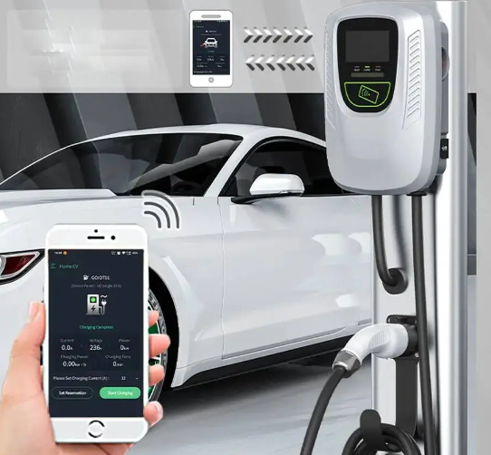

**ADVANTAGES:**

1. Convenience for users.

2. Real-time monitoring.

3. Improved efficiency.

4. Potential cost savings.

5. Inclusivity for various users.

**DISADVANTAGES:**

1. Initial setup costs.

2. Dependency on RFID cards.

3. Limited compatibility.

4. Consist of Security risks.

5. Maintenance requirements are needed

**CHAPTER 4**

**HARDWARE COMPONENTS**

# 4.1 NodeMCU ESP8266 MICROCONTROLLER

NodeMCU ESP8266 (ESP-12e) is the name of a micro controller designed by Espressif Systems. The ESP8266 itself is a self-contained Wi-Fi networking solution acting as a bridge between the existing micro controller to Wi-Fi and is also capable of running self-contained applications. This module comes with a built in USB connector and a rich assortment of pin-outs. With a micro-USB cable, you can connect NodeMCU kit to your laptop and flash it without any trouble, just like Arduino. It is also immediately breadboard friendly. Firmware.By exploring functionality with ESP8266 chip, NodeMCU firmware comes with ESP8266 Development board/kit Since NodeMCU is open-source platform, their hardware design is open for edit/modify/build. NodeMCUDev Kit/board consist of ESP8266 WIFI enabled chip. The ESP8266 is a low-cost Wi-Fi chip developed by Espressif Systems with TCP/IP protocol. i.e., NodeMCU Development board.

The NodeMCU is available in various package styles. Common to all the designs is the base ESP8266 core. Designs based on the architecture have maintained the standard 30-pin layout. Some designs use the more common narrow (0.9″) footprint, while others use a wide (1.1″) footprint – an important consideration to be aware of.

The most common models of the NodeMCU are the Amica (based on the standard narrow pin-spacing) and the LoLin which has the wider pin spacing and larger board. The open-source design of the base ESP8266 enables the market to design new variants of the NodeMCU continually.

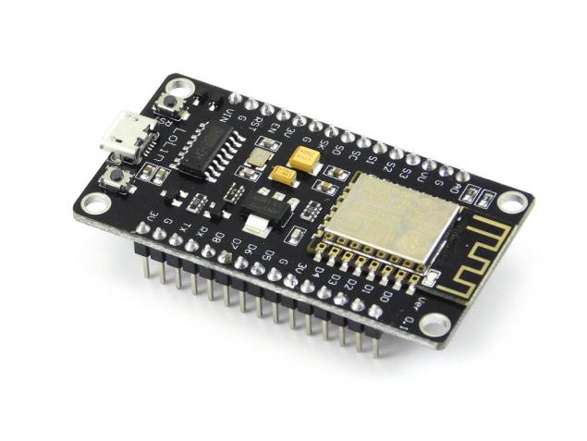

# 4.2 RFID SCANNER

RFID technology is a method of data collection that involves automatically identifying objects through low-power radio waves. Data is sent and received with a system consisting of RFID tags, an antenna, a RFID reader, and a transceiver.

An RFID reader (Radio Frequency Identification Reader) is a tool used to collect data from an RFID tag, which is used to track certain objects. Data from the tag to the reader is transferred using radio frequency waves. An RFID reader must be able to read the RFID tag in order for it to do so. RFID technology provides speedy scanning of several objects and quick identification of a specific product, even when it is surrounded by several other things.

**PRODUCT DESCRIPTION**

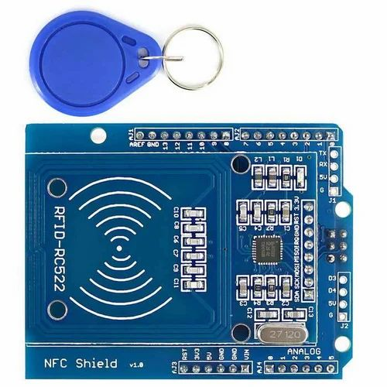

This RC522 RFID Card Reader Module 13.56MHz is a low-cost MFRC522 based RFID Reader Module is easy to use and can be used in a wide range of applications.

The MFRC522 is a highly integrated reader/writer IC for contactless communication at 13.56 MHz

RC522 is the highly integrated RFID card reader which works on non-contact 13.56mhz communication, is designed by NXP as low power consumption, low cost and compact size read and write chip, is the best choice in the development of smart meters and portable hand-held devices.

# 4.3 LIQUID CRYSTAL DISPLAY

LCD is a type of flat panel display that uses liquid crystals to produce images in colour or monochrome. It is a thin display device that allows displays to be thinner than cathode ray tube (CRT) technology. LCDs consume less power than LED and gas-display displays because they work on the principle of blocking light. They are commonly used in computer monitors, instrument panels, cell phones, digital cameras, TVs, laptops, tablets, and calculators. LCD displays contain a backlight rather than the firing electrons at a glass screen, which offers light to individual pixels arranged in a rectangular grid. The millions of colour combinations can be possible with the help of adjusting individual levels of red, green, and blue light. As LCDs have replaced older display technologies, new display technologies like OLEDs have started to replace LCDs.

**PRODUCT DESCRIPTION**

Character LCDs can display characters only and are divided into rows of characters. For example a 2 by 16 character LCD display has two lines that can display 16 characters each. An example of a 2 × 16 character display is shown below.

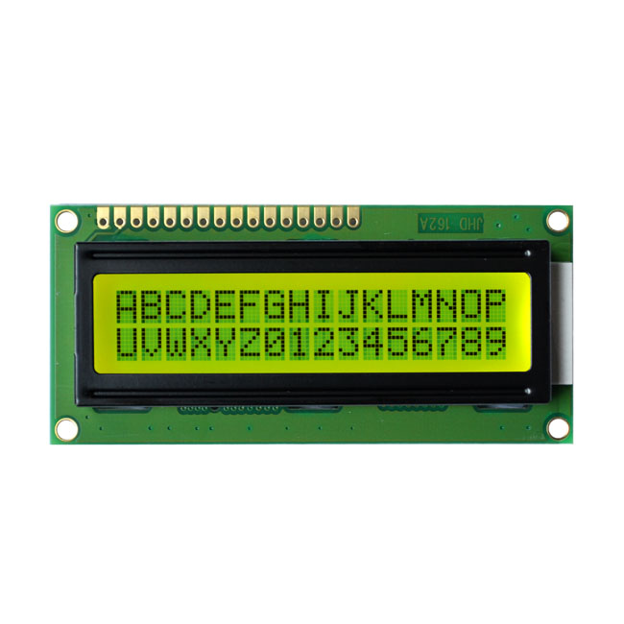

# 4.4 RELAY

Relays are the switches that aim at closing and opening the circuits electronically as well as electromechanically. It controls the opening and closing of the circuit contacts of an electronic circuit. When the relay contact is open (NO), the relay isn’t energized with the open contact. However, if it is closed (NC), the relay isn’t energized given the closed contact. However, when energy (electricity or charge) is supplied, the states are prone to change.

Relays are normally used in the control panels, manufacturing, and building automation to control the power along with switching the smaller current values in a control circuit. However, the supply of amplifying effect can help control the large amperes and voltages because if low voltage is applied to the relay coil, a large voltage can be switched by the contacts.

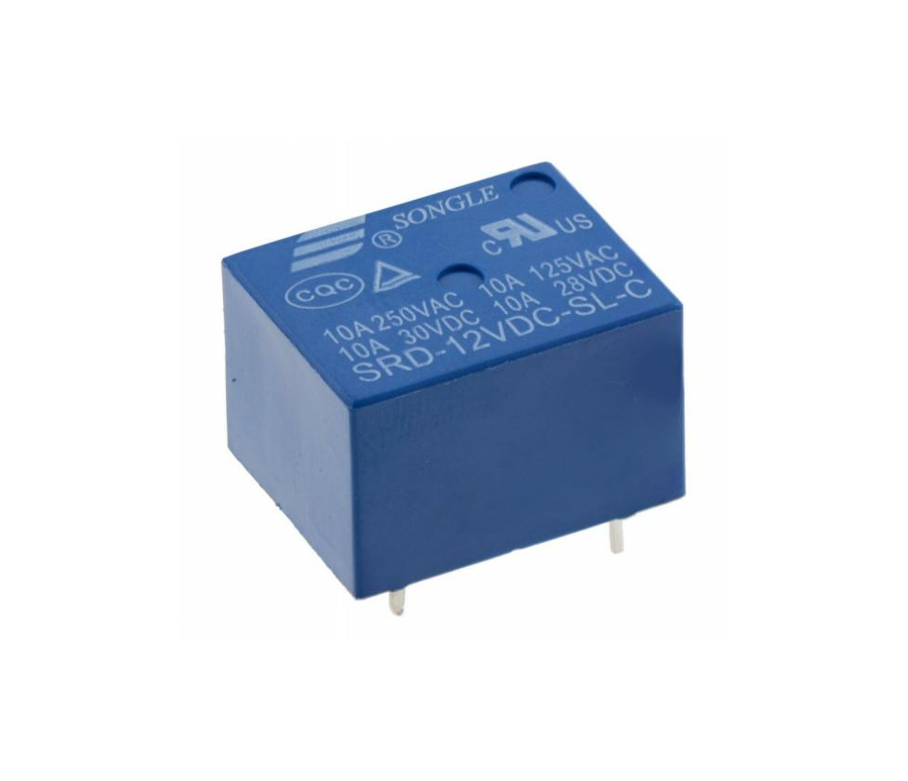

**CHAPTER 5**

**SOFTWARE COMPONENTS**

# 5.1 ARDUINO IDE

The Arduino Integrated Development Environment (IDE) is a cross-platform application (for Windows, macOS, Linux) that is written in functions from C and C++. It is used to write and upload programs to Arduino compatible boards, but also, with the help of 3rd party cores, other vendor development boards. The Arduino Integrated Development Environment - or Arduino Software (IDE) - contains a text editor for writing code, a message area, a text console, a toolbar with buttons for common functions and a series of menus. It connects to the Arduino hardware to upload programs and communicate with them.



# 5.2 GOOGLE FIREBASE

Firebase is a mobile and web app development platform that provides developers with a plethora of tools and services to help them develop high- quality apps, grow their user base, and earn more profit. It also provides real- time databases for the developers to store their data for future purposes and use. The Real-time Database is a cloud-hosted NoSQL database that lets you store and sync between your users in real-time. The Real-time Database is really 39 just one big JSON object that the developers can manage in real-time. With just a single API, the Firebase database provides your app with both the current value of the data and any updates to that data. Real-time syncing makes it easy for your users to access their data from any device, be it web or mobile. Real- time Database also helps your users collaborate with one another.

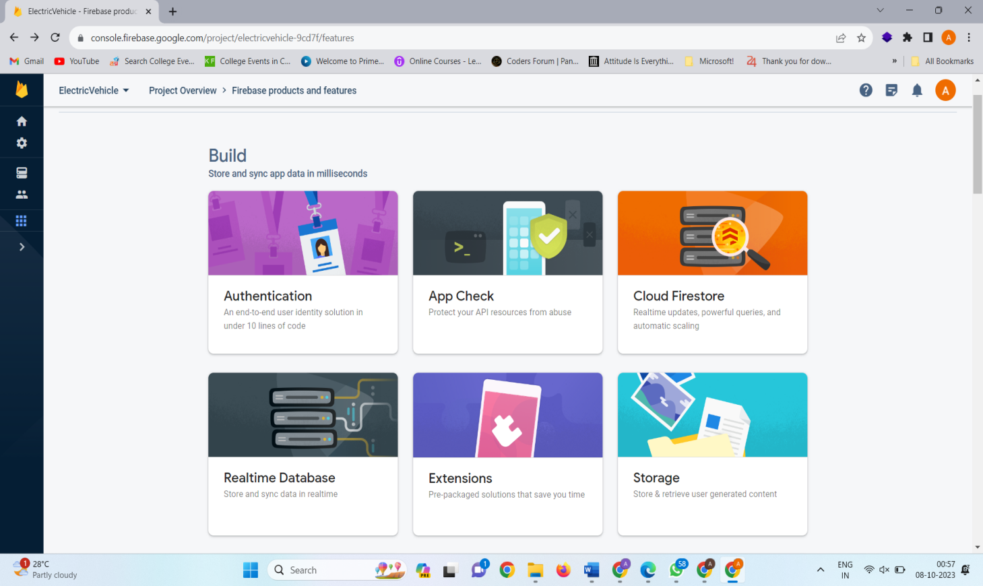

# 5.3 GOOGLE STYLESHEET

Google Sheets is a free web-based spreadsheet application compatible with Microsoft Excel file formats. It allows users to create and edit files online while collaborating with other users in real-time. Updates have introduced features that use machine learning, including "Explore". It is an amazing data analysis tool that users can leverage to understand complex data sets by generating easy-to-read and understand graphs. Users can customize their graphs to suit their preferences and data needs.



# 5.4 MIT APP INVENTOR

MIT App Inventor is an online user-friendly tool to create android apps. It is a web application integrated development environment, a high-level block-based visual programming language, originally built by Google and now maintained by the Massachusetts Institute of Technology.

The web interface consists of a graphical user interface (GUI) very similar to [Scratch](https://en.wikipedia.org/wiki/Scratch_(programming_language)" \o "Scratch (programming language)) and [Star Logo](https://en.wikipedia.org/wiki/StarLogo" \o "StarLogo), allowing users to drag-and-drop visual objects to create an application that can be tested on Android and iOS devices and compiled to run as an Android app. It uses a companion mobile app named MIT AI2 Companion providing live testing and debugging.

App Inventor provides integration with different online services, such as [Google Sheets](https://en.wikipedia.org/wiki/Google_Sheets" \o "Google Sheets) and [Firebase](https://en.wikipedia.org/wiki/Firebase" \o "Firebase).



**CHAPTER 6**

**HARDWARE IMPLEMENTATION**

**6.1 ARDUINO IDE**

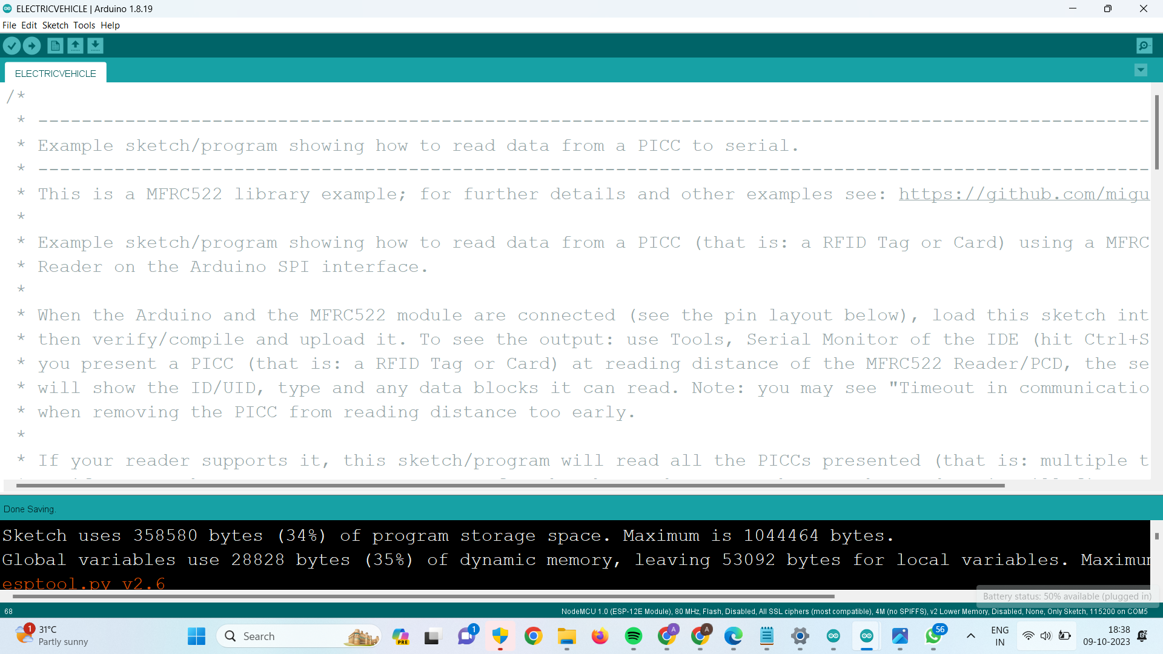

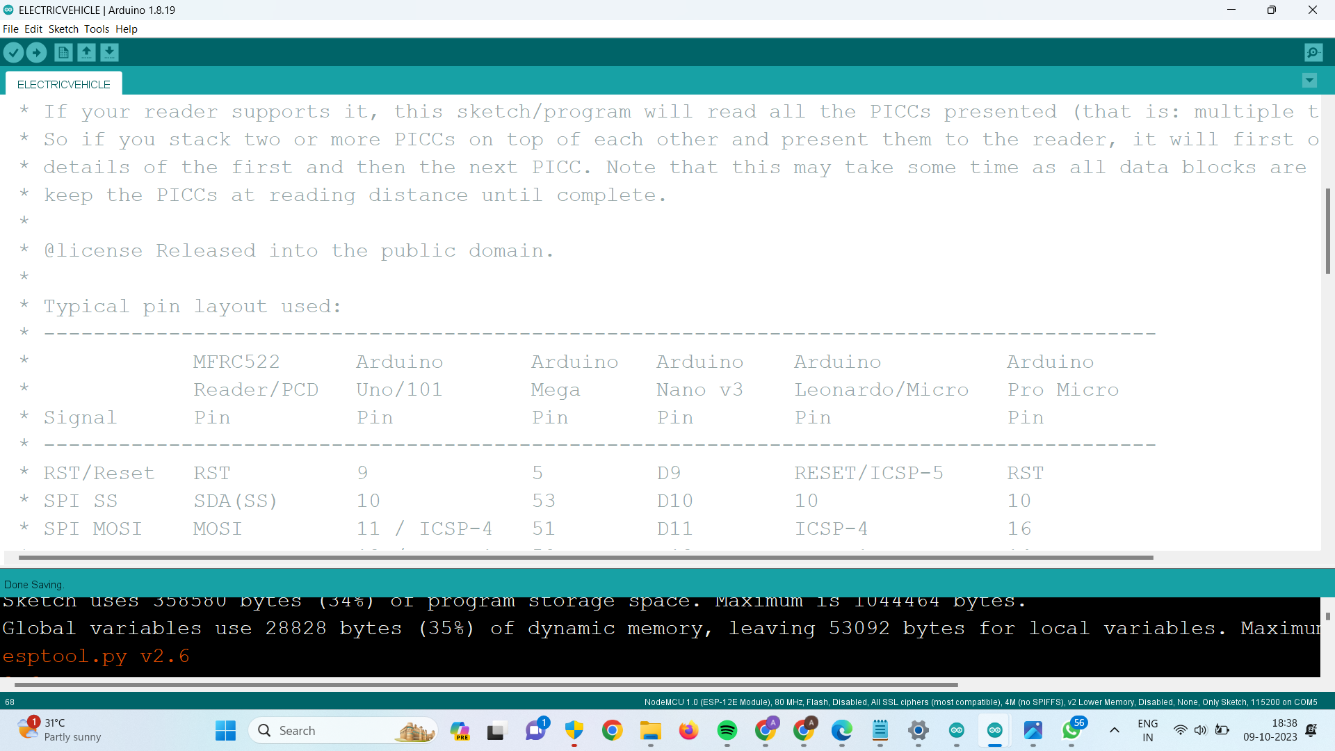

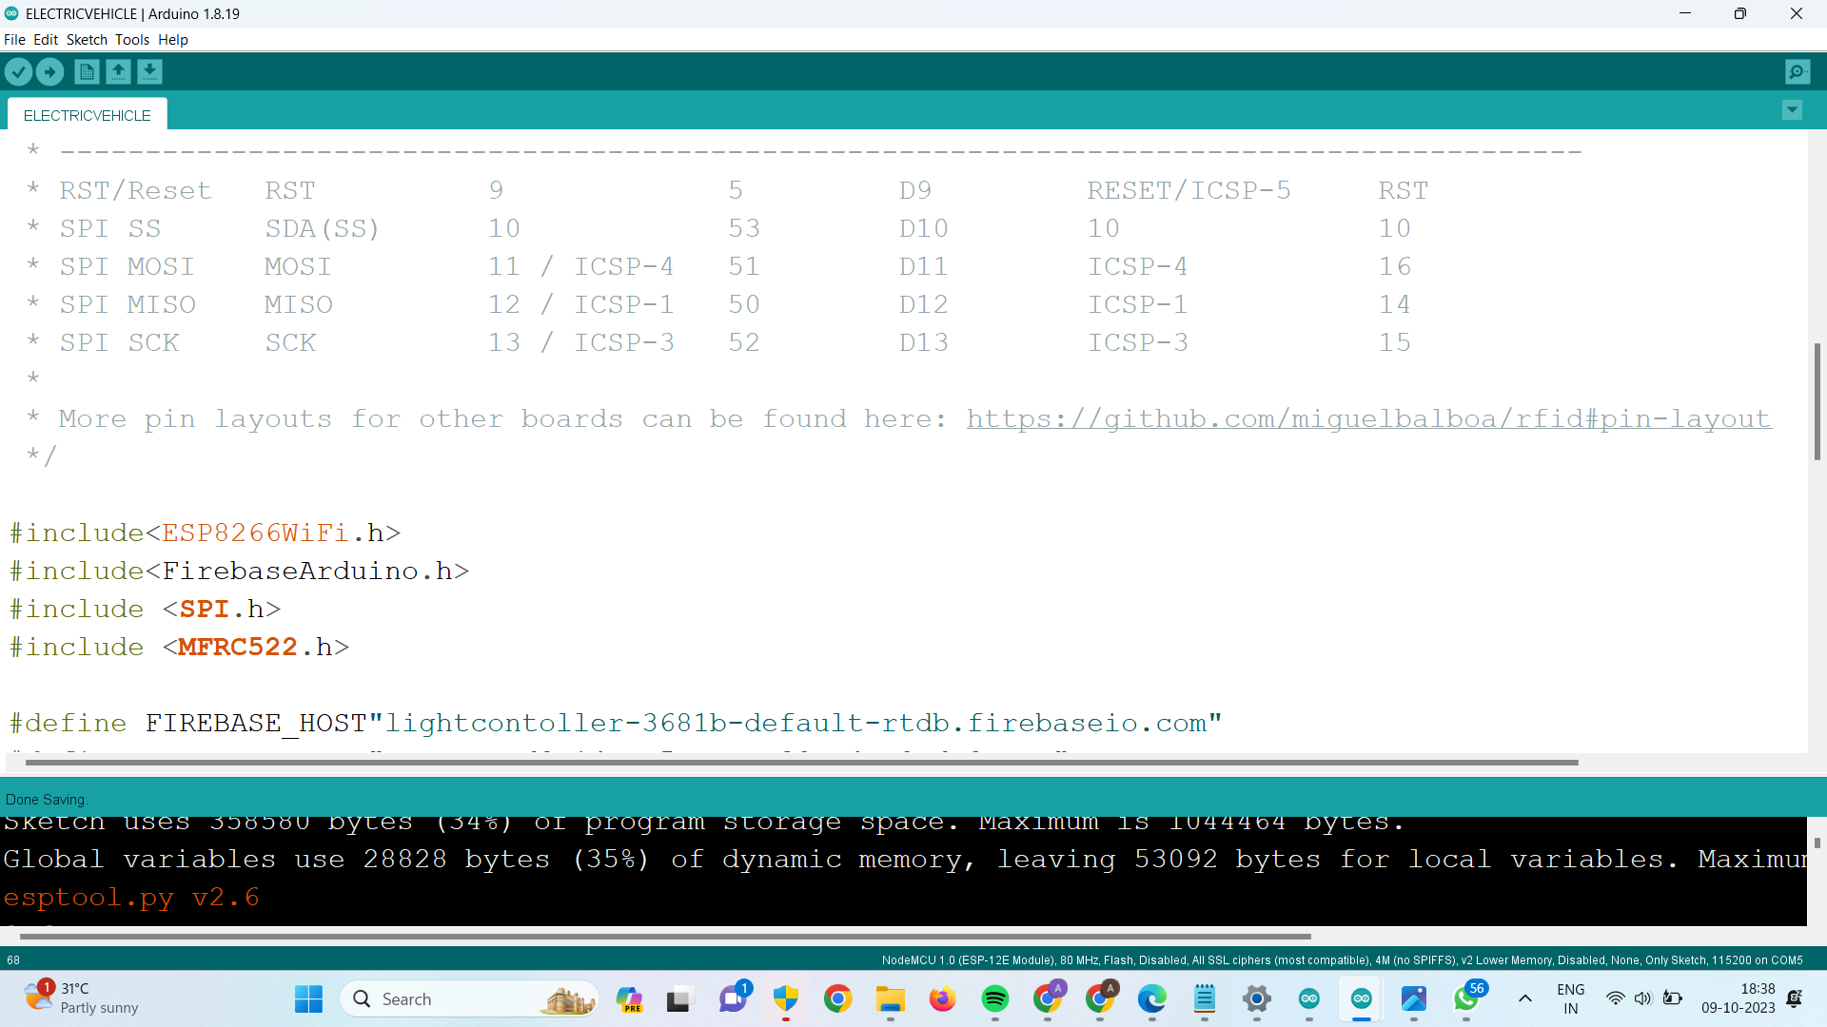

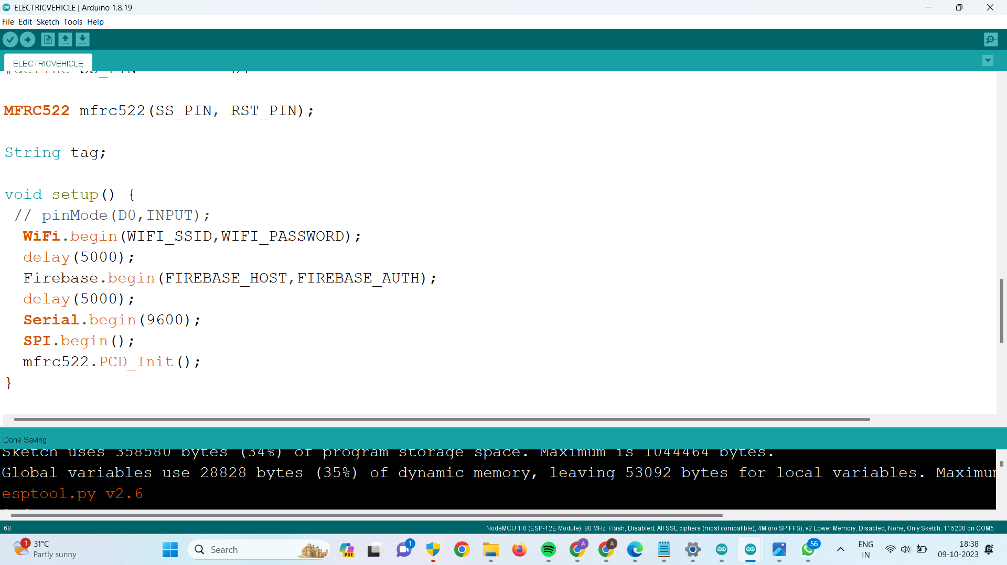

**SOFTWARE IMPLEMENTATION**

**CHAPTER 7**

**7.1 FIRBEBASE**



**7.2 MIT APP INVENTOR FRONT END**

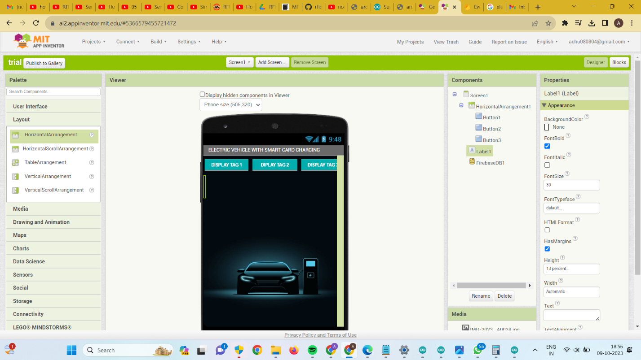

**7.3 MIT APP INVENTOR BACKEND**

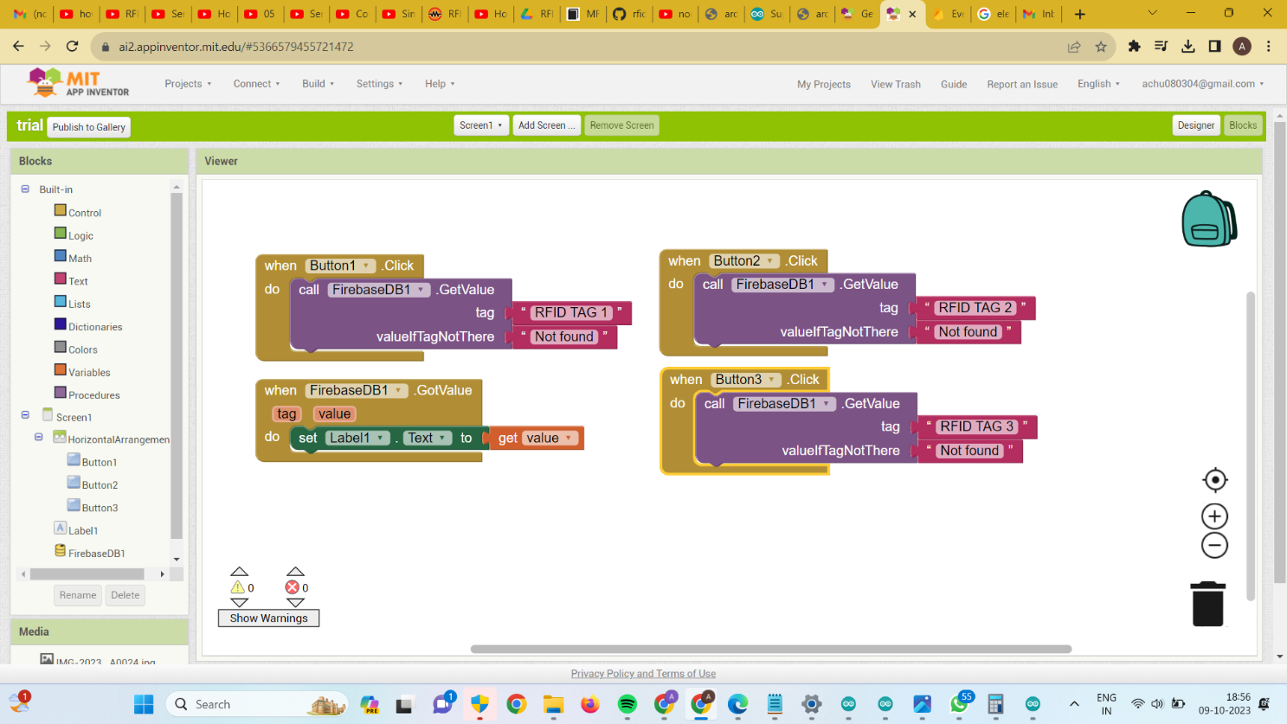

**7.3 ICON**

**EVEHICLE**

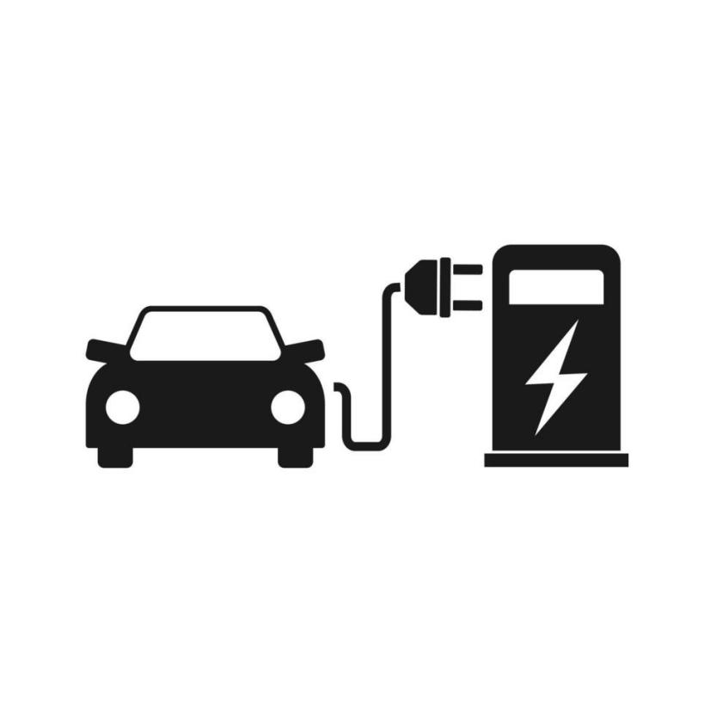

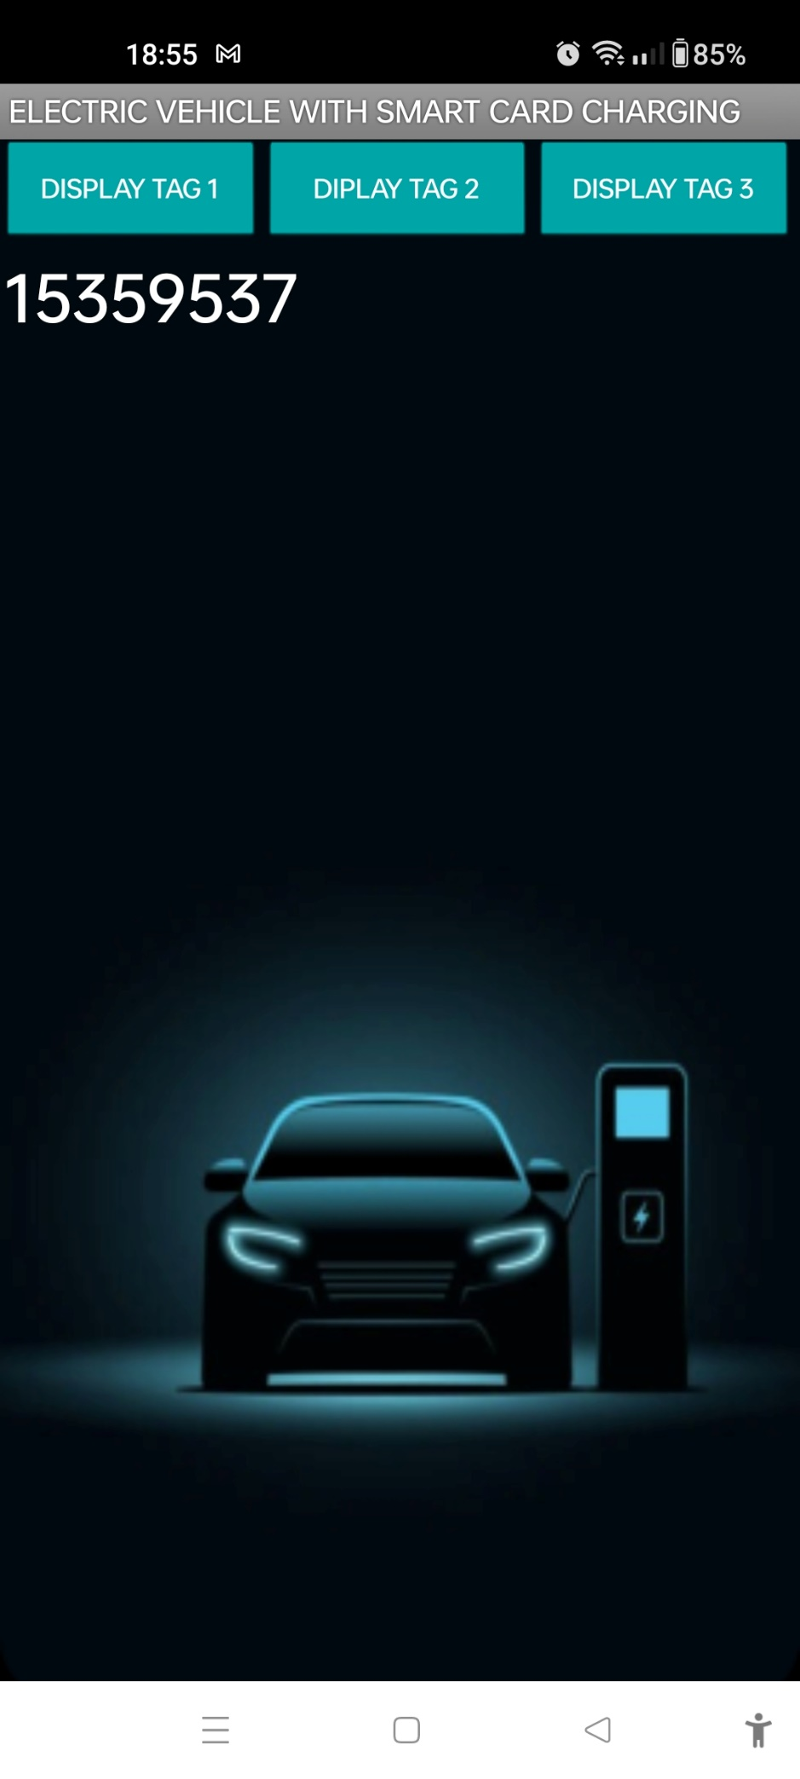

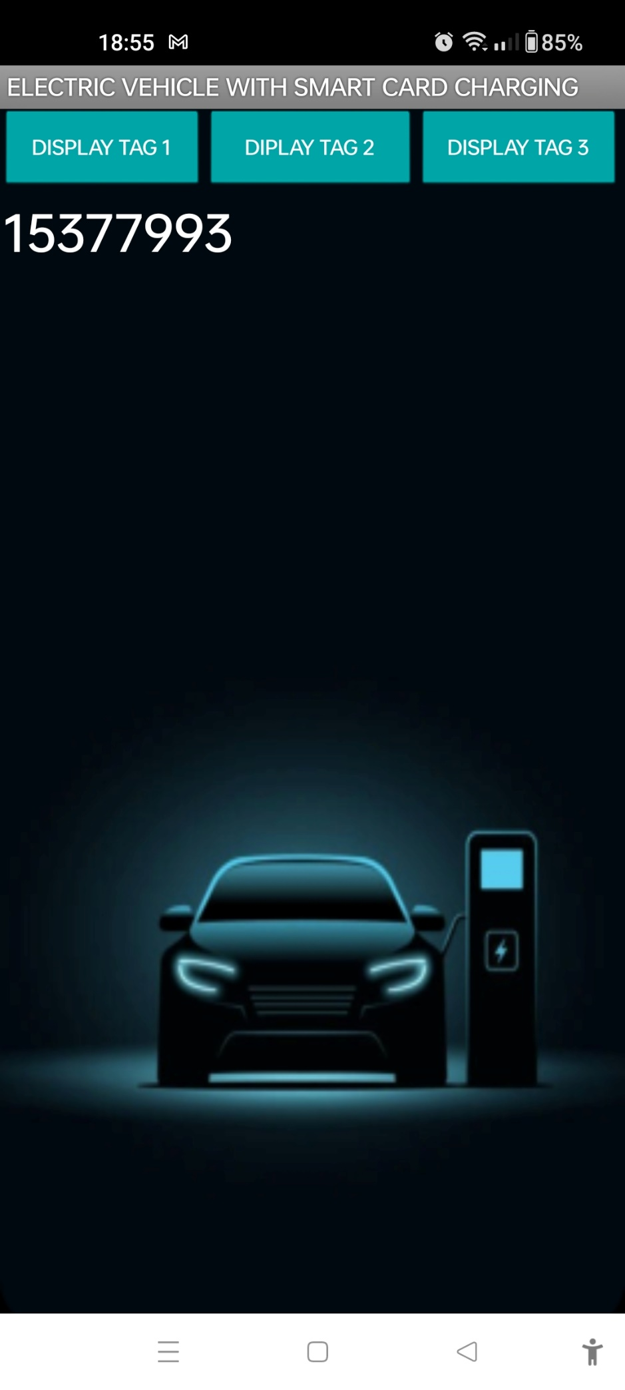

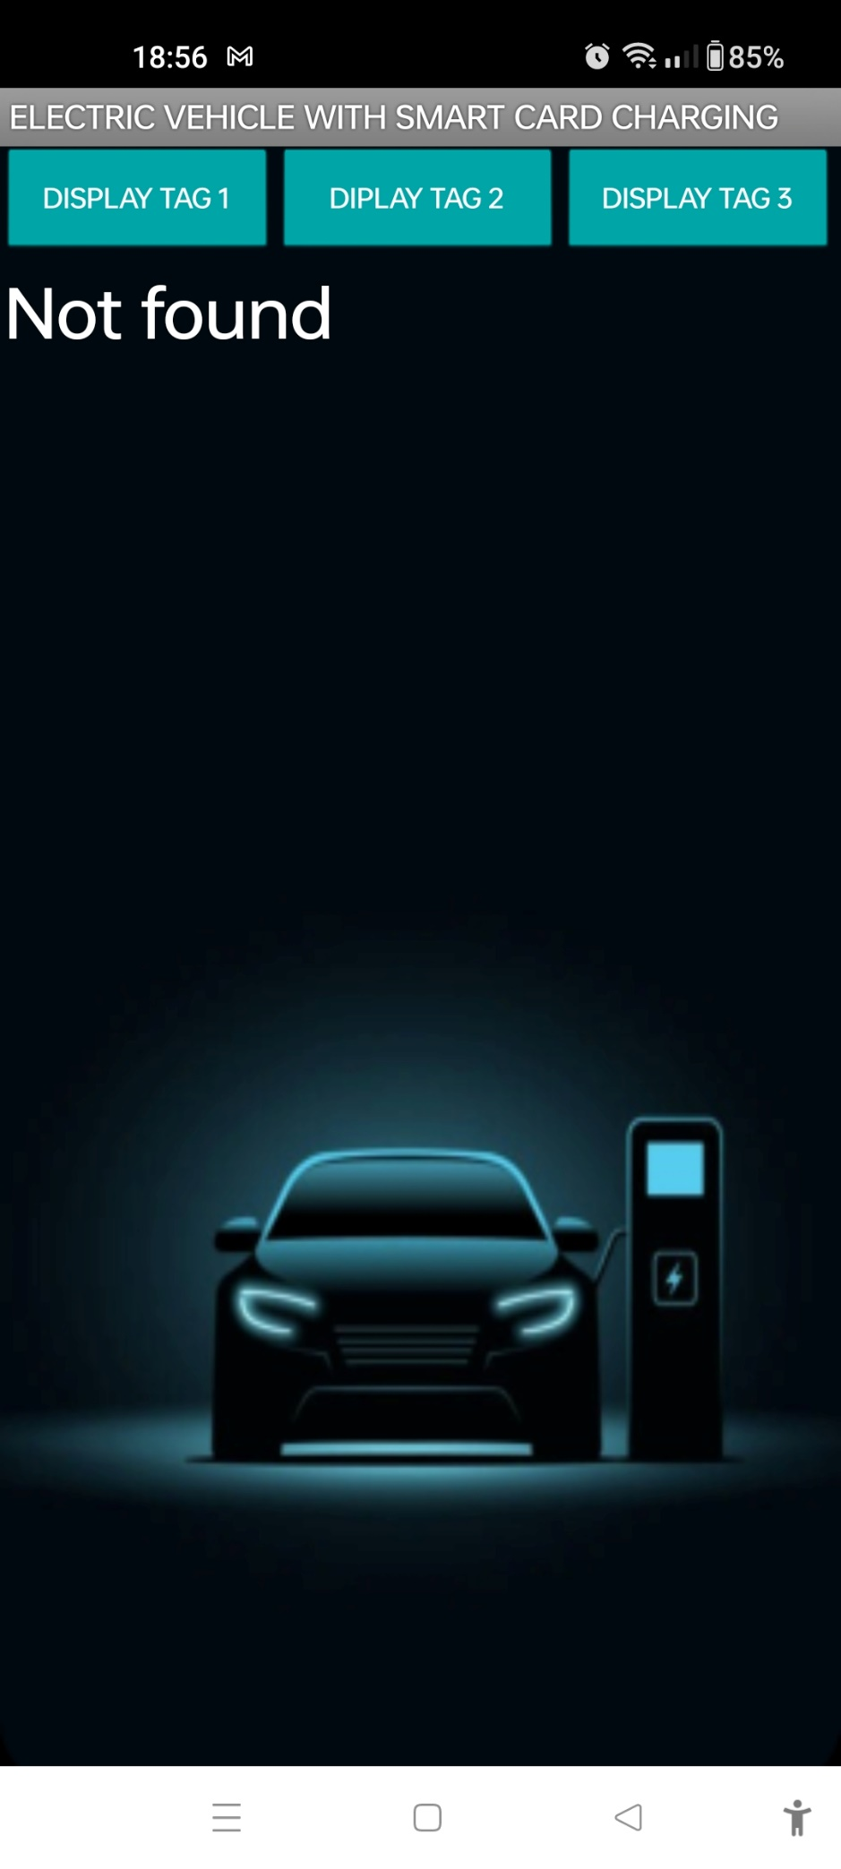

**CHAPTER 8**

**CONCLUSION**

The project described focuses on developing a Smart Card-Enabled Charging System for Electric Vehicles (EVs) using RFID technology and IoT components. This system aims to address the growing demand for efficient and convenient EV charging infrastructure as the adoption of electric vehicles increases worldwide. The proposed system integrates hardware components like NodeMCU ESP8266 microcontroller, RFID scanner, LCD display, and relays with software components like Arduino IDE, Google Firebase, and MIT App Inventor to create a seamless and user-friendly charging experience for EV owners.

The existing system limitations, such as time-consuming charging, inability to charge multiple vehicles simultaneously, and high setup costs, are addressed by the proposed system. The introduction of RFID technology enables secure user identification and payment, ensuring a more accessible and practical EV charging experience. The system also offers real-time monitoring and displays important charging information, enhancing the overall user experience.

**FUTURE SCOPE**

**CONCLUSION**

In the future, the Smart Card-Enabled Charging System for Electric Vehicles has significant potential for expansion and enhancement. It can be scaled to accommodate a growing number of charging stations and electric vehicles, meeting the rising demand for EV charging infrastructure. Integration with renewable energy sources, such as solar panels and wind turbines, offers a sustainable and eco-friendly charging option. The development of dedicated mobile applications can improve user convenience, while advanced authentication methods like biometrics can enhance security. Grid integration, predictive maintenance, and data analytics can optimize system performance, and adapting to international standards and forming partnerships can drive wider adoption. Overall, this system represents a step towards a more efficient, user-friendly, and environmentally responsible EV charging infrastructure, vital for the growing electric vehicle market and reducing transportation-related emissions.

**CHAPTER 9**

**REFERENCES**

[1]. Wallbox website, URL: <https://wallbox.com/en_catalog/faqs-what-is-smart-charging>.

[2]. J. Joyce Jacob,Abinaya.S,Divya Priya. R, Ms. Poonam Khatarkar, Abdullaeva Barno, G. Sathish Kumar : Electric Vehicle Wireless Charging using RFID, at: <https://www.e3s-conferences.org/articles/e3sconf/pdf/2023/36/e3sconf_iconnect2023_01010.pdf>

[3]. Driivz website, URL: https://driivz.com/blog/ev-charging-technology-innovations/

[4]. McKinsey & Company website, URL: https://www.mckinsey.com/industries/automotive-and-assembly/our-insights/perspectives-on-wireless-and-automated-charging-for-electric-vehicles

[5]. Electric Vehicle Charging Open Payment Framework with ISO 15118, Publication Date: February 2021, at : https://www.securetechalliance.org/wp-content/uploads/EV-Charging-Open-Pmt-Framework-WP-FINAL2-Feb-2021.pdf

[6]. Encstore website,

URL: https://www.encstore.com/blog/5447-rfid-smart-card-for-ev-charging#:~:text=The%20best%20method%20of%20integrating,to%20charge%20their%20vehicles%20easily

[7].Print Plast website, URL:https://www.printplast.com/ev-charging-card/

[8]. Dr. Manoj Dhondiram Patil, Mr. Suraj More, Mr. Pranav Patil, Mr. Rohit Mortale, Miss. Komal Khot : Smart Card Based Electric Vehicle Charging Station, at : https://ijarsct.co.in/Paper3227.pdf

[9]. A. Ajithkumar1, M. Ajithkumar, S. Gopi, V.G. Balajisabarinathan, Mr. C. Gowrishankar : SMART E-VEHICLE CHARGING SYSTEM USING RFID, at : <https://www.ijrar.org/papers/IJRAR19L2037.pdf>